create-react-app recipes-app

npm install --save bootstrap

npm install --save react-router-dom

1. Index.html
2. 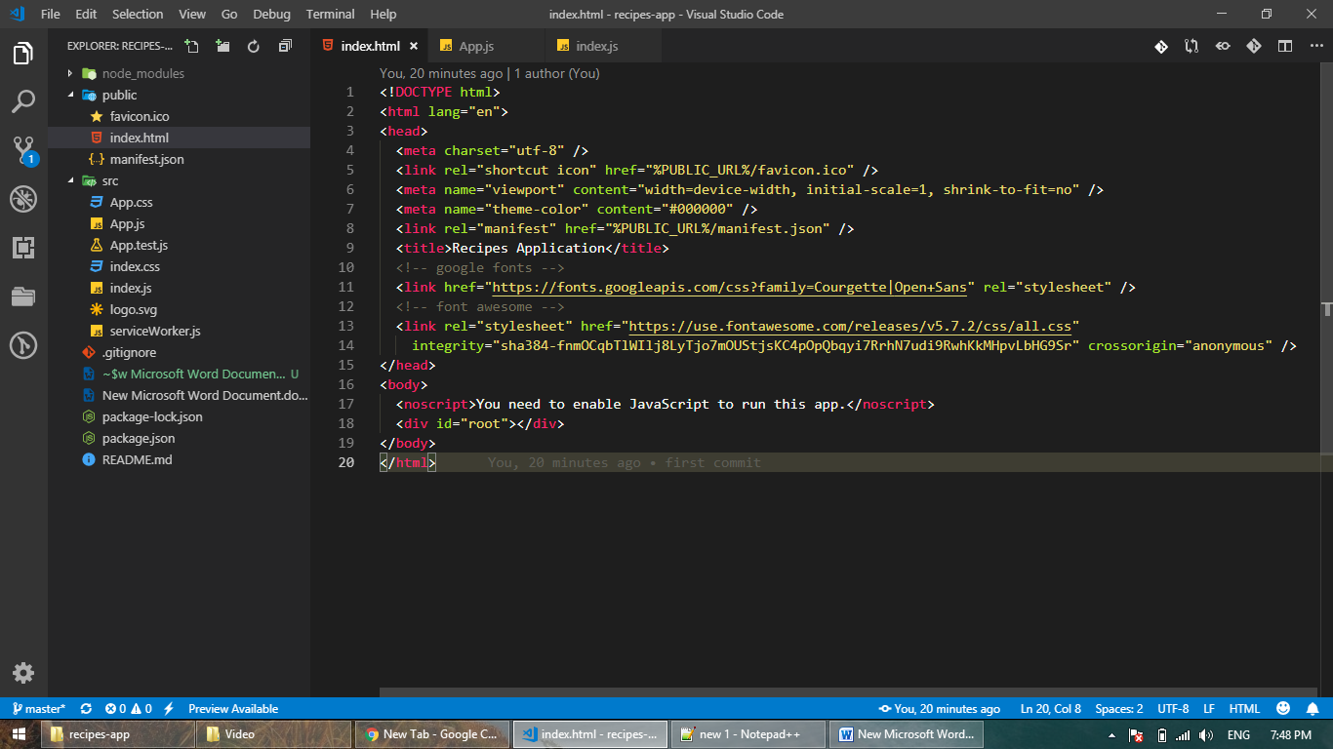
3. App.js
4. import React, { Component } from 'react';
5. import './App.css';
6. import "bootstrap/dist/css/bootstrap.min.css";
7. *class* App extends *Component* {
8. render() {
9. return <div>hello from our recipe app</div>;
10. }
11. }
12. export default App;
13. 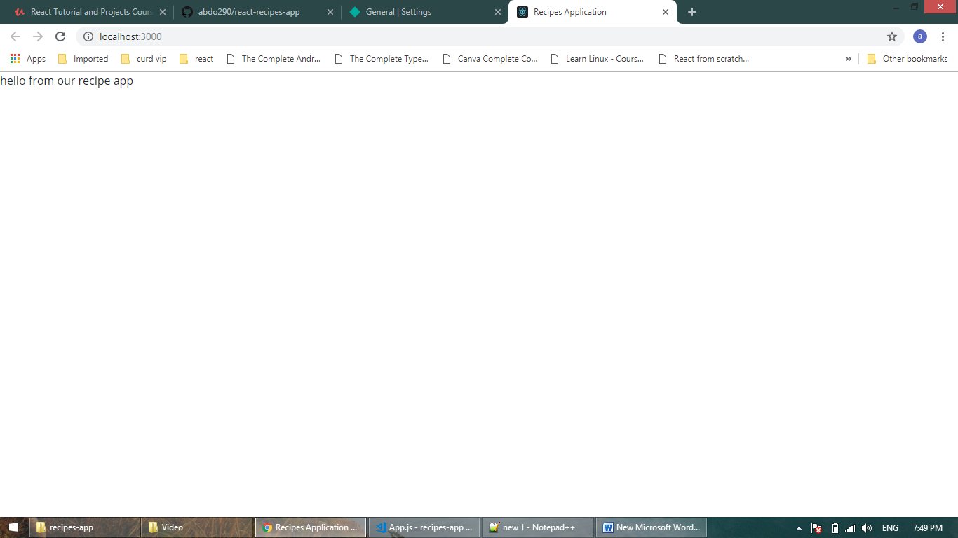
14. Create pages
15. 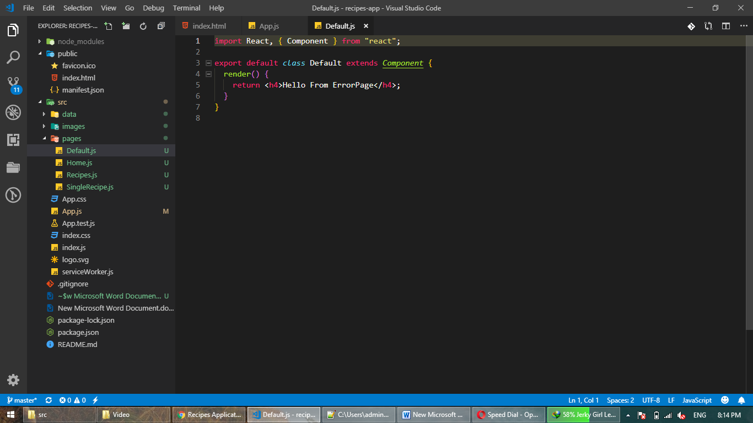
16. 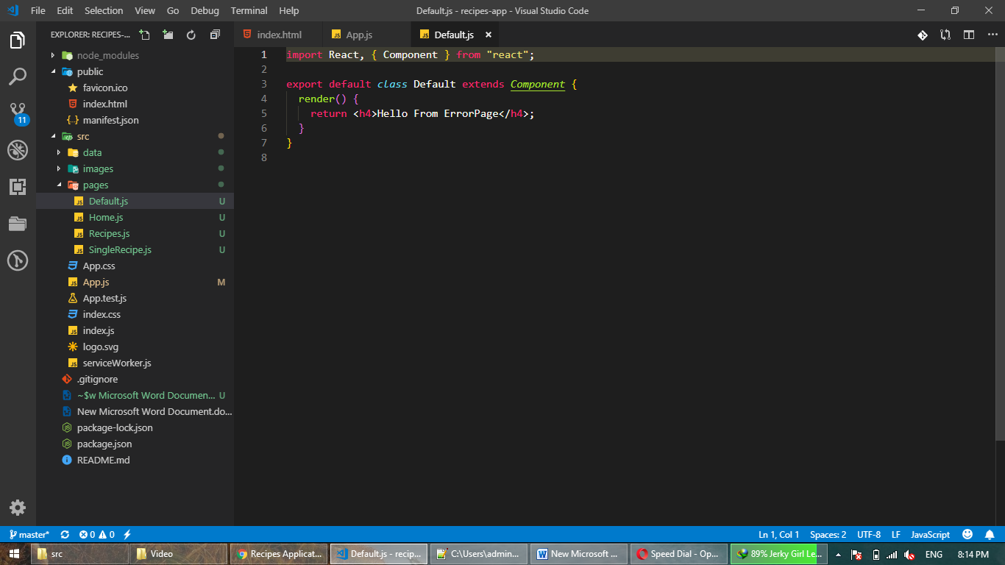
17. 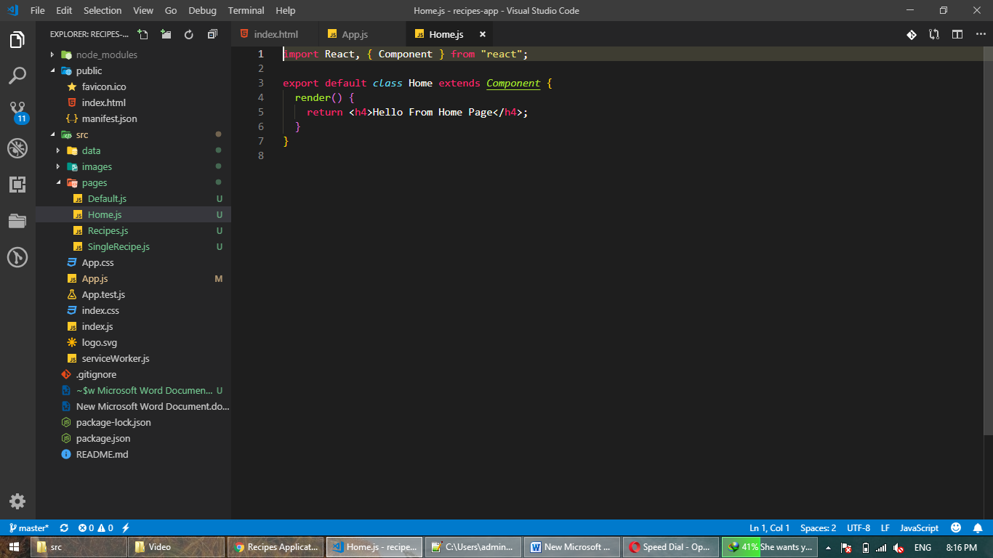
18. 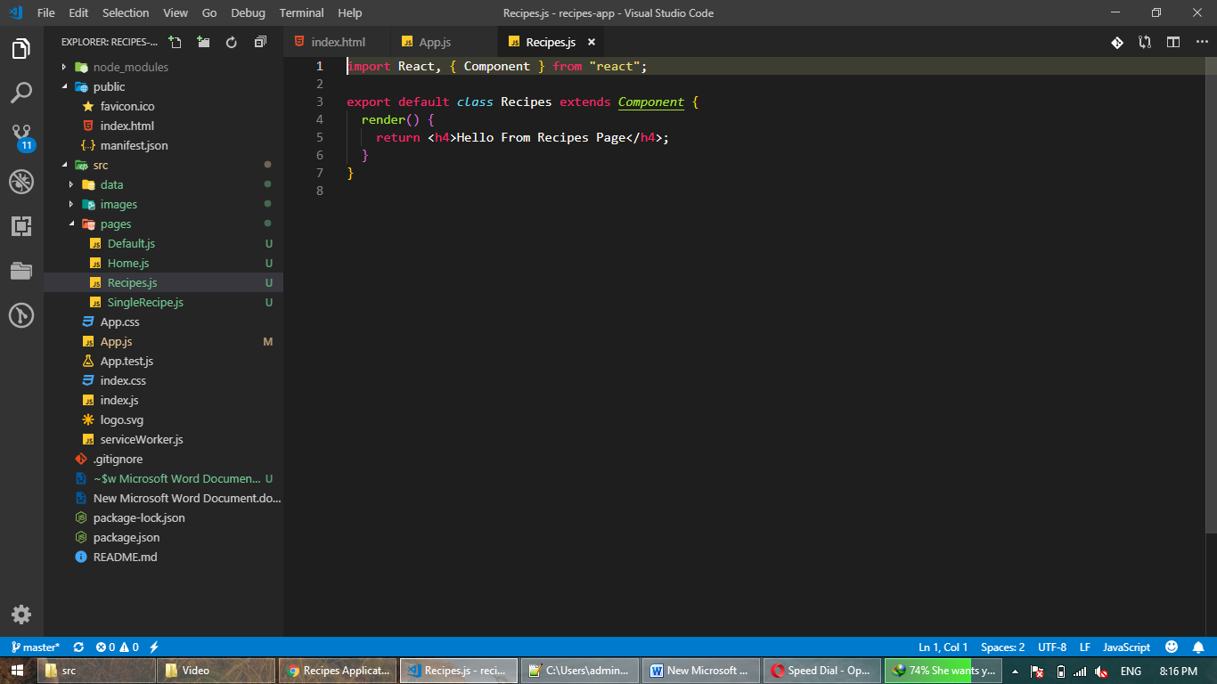
19. 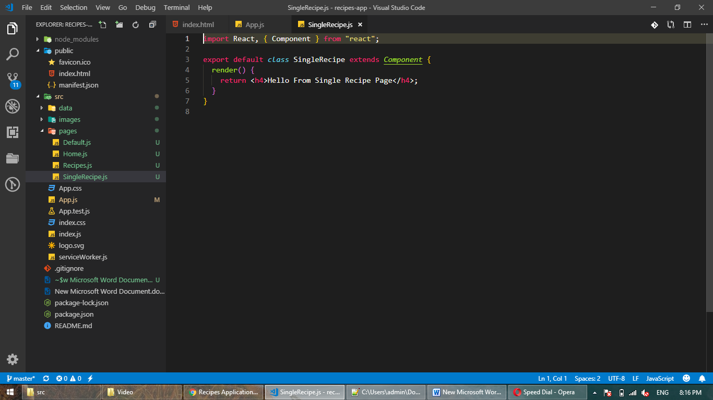
20. App.js
21. 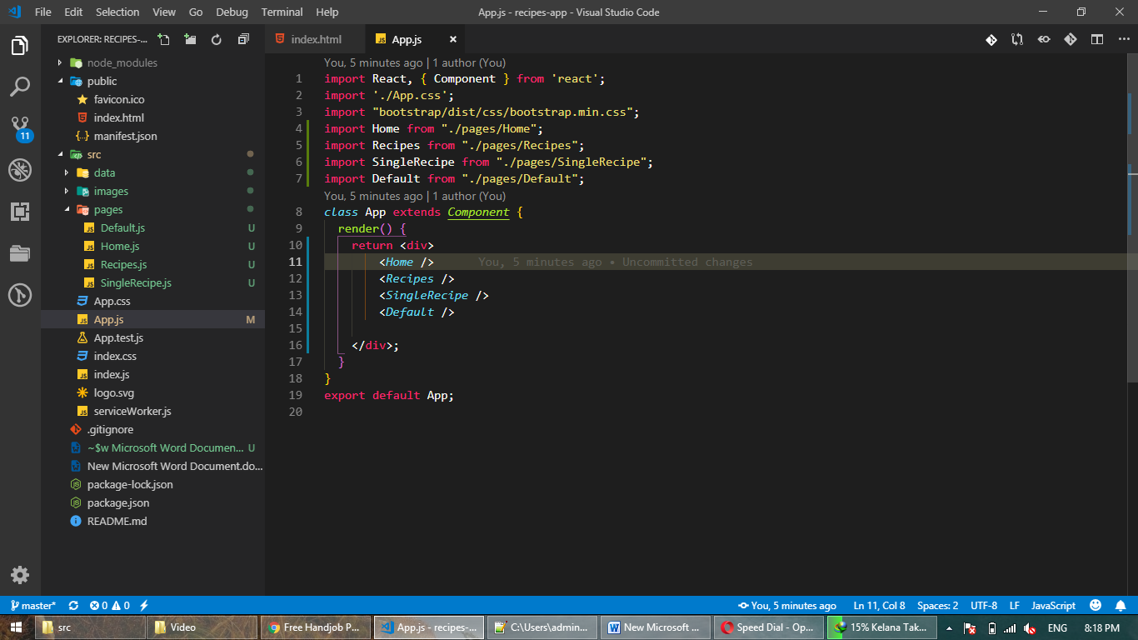
22. Setup React routr
23. 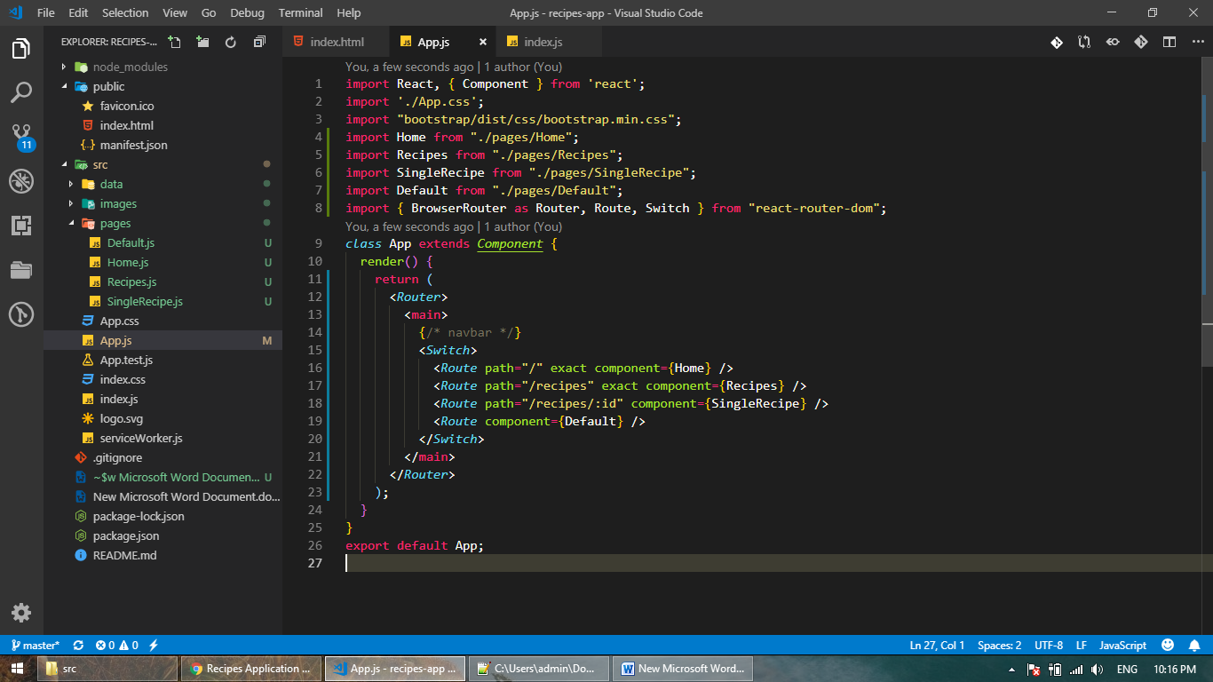
24. Navbar
25. 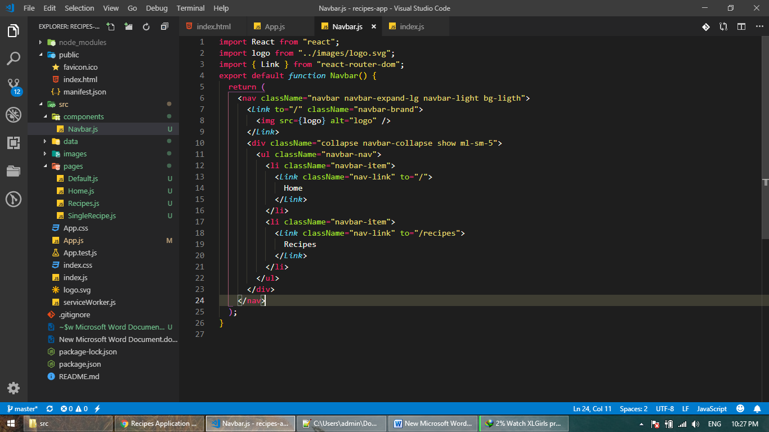
26. App.js
27. 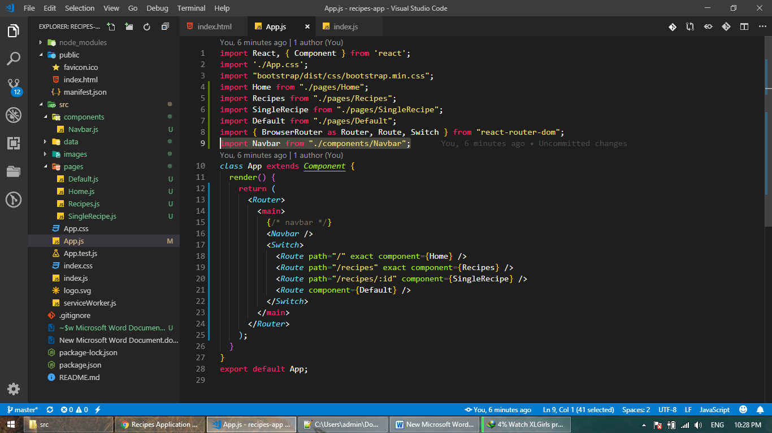
28. 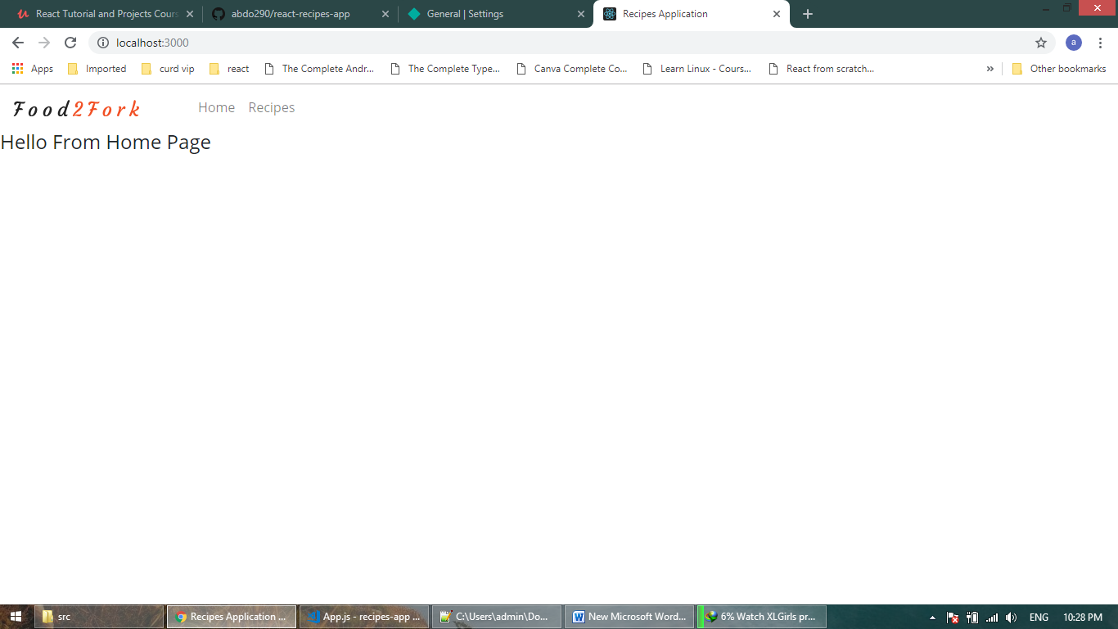
29. Header.js
30. 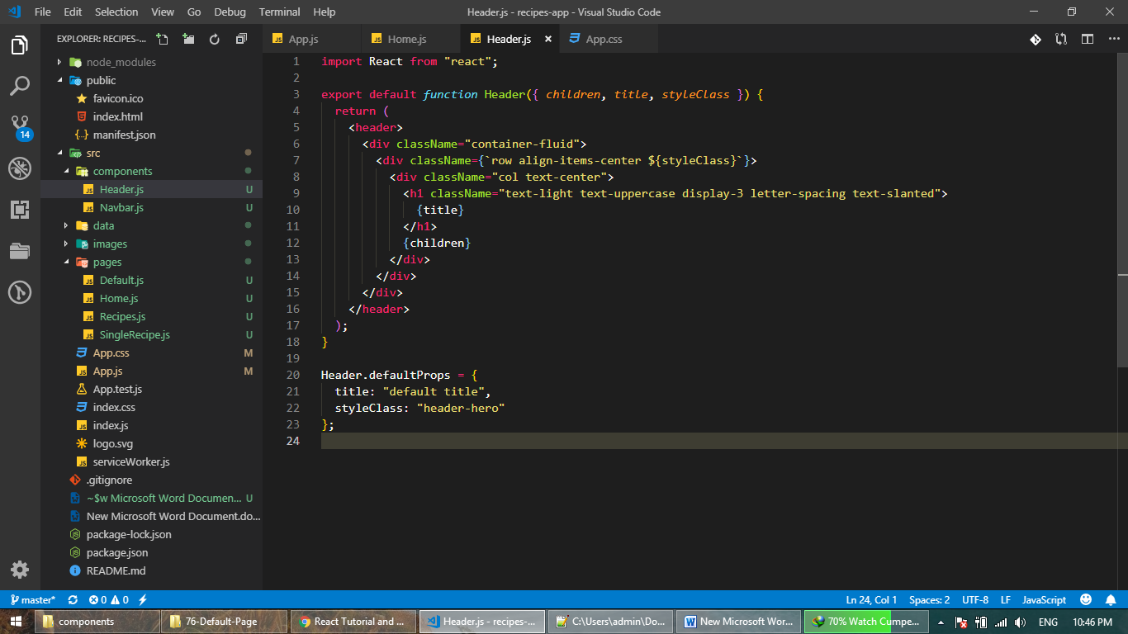
31. Home.js
32. 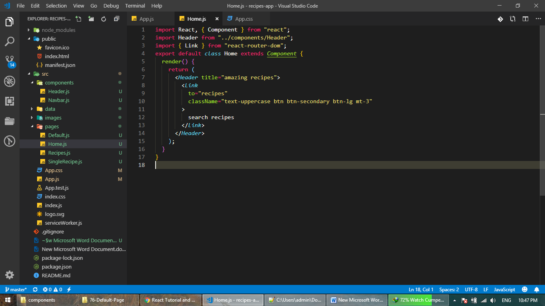
33. App.css
34. 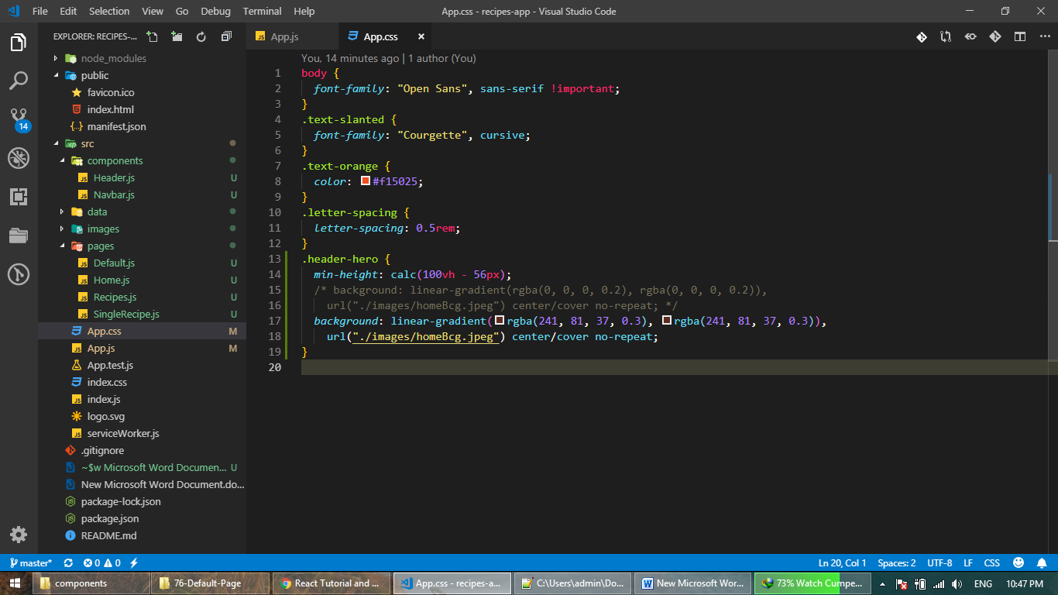
35. 